**MCInc vs MCIc – X axis (sagittal plane)**



**Approach 1 - 2019_04_24_10_52**

**Network:**

Transfer learning from AlexNet changing last 3 layers.

|  |  |
| --- | --- |
| **Training parameters:**   * folds=3; * miniBatchSize = 64; * learningRate = 1e-4; * maxEpochs=30; * optimizer='sgdm'; * "L2Regularization", 0.0001 * %"Momentum", 0.889 * %'Shuffle','every-epoch' | **Dataset:**   * nSlices=6; * gap=2; |

**Results:**

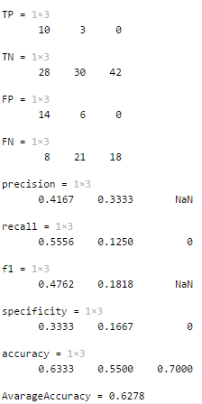

**Approach 2 - 2019_04_24_11_04**

**Network:**

Transfer learning from AlexNet changing last 3 layers.

|  |  |
| --- | --- |
| **Training parameters:**   * folds=3; * miniBatchSize = 30; * learningRate = 1e-4; * maxEpochs=20; * optimizer='sgdm'; * "L2Regularization", 0.0001 * %"Momentum", 0.889 * %'Shuffle','every-epoch' | **Dataset:**   * nSlices=6; * gap=2; |

**Results:**

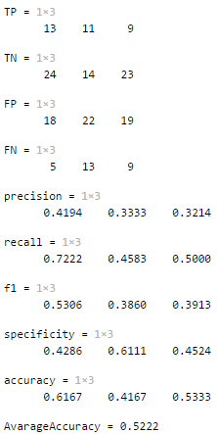

**Approach 3 - 2019_04_24_11_13**

**Network:**

Transfer learning from AlexNet changing last 3 layers.

|  |  |
| --- | --- |
| **Training parameters:**   * folds=3; * miniBatchSize = 36; * learningRate = 1e-4; * maxEpochs=50; * optimizer='sgdm'; * "L2Regularization", 0.0001 * %"Momentum", 0.889 * %'Shuffle','every-epoch' | **Dataset:**   * nSlices=6; * gap=2; |

**Results:**

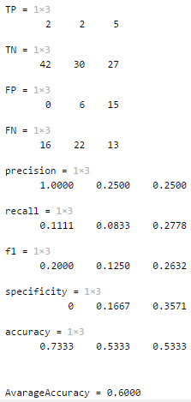

**Approach 4 - 2019_04_24_11_32**

**Network:**

Transfer learning from AlexNet changing last 3 layers.

|  |  |
| --- | --- |
| **Training parameters:**   * folds=3; * miniBatchSize = 20; * learningRate = 1e-4; * maxEpochs=24; * optimizer='sgdm'; * "L2Regularization", 0.0001 * %"Momentum", 0.889 * %'Shuffle','every-epoch' | **Dataset:**   * nSlices=6; * gap=2; |

**Results:**

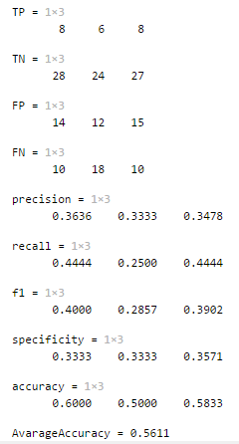

**Approach 5 - 2019_04_24_12_10**

**Network:**

Transfer learning from AlexNet changing last 3 layers.

|  |  |
| --- | --- |
| **Training parameters:**   * folds=3; * miniBatchSize = 20; * learningRate = 1e-4; * maxEpochs=24; * optimizer='sgdm'; * "L2Regularization", 0.0001 * "Momentum", 0.889 * 'Shuffle','every-epoch' | **Dataset:**   * nSlices=6; * gap=2; |

**Results:**

